Sequence of report

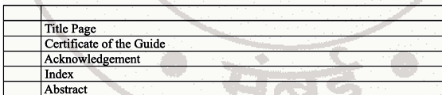

After that chapters

Typographical Instructions for Project Report Writing
- The project report shall be computer typed in English and printed on A4 size paper only.
- The font style used for the entire report shall be Times New Roman (TNR) with font size 12 points for normal text.
- Subsection headings shall be typed in Times New Roman, 12-point size, and bold format.
- Section headings shall be typed in Times New Roman, 14-point size, capital letters, and bold format.
- Chapter names or topic names shall be typed in Times New Roman, 16-point size, capital letters.
- All text in the project report shall be fully justified using paragraph alignment settings.
- The report shall be typed on one side of the paper only with 1.5 line spacing.
The margins shall be:
  - Left margin: 3.5 cm
  - Top margin: 2.5 cm
  - Right margin: 1.25 cm
  - Bottom margin: 1.25 cm
- Don’t use borders for any pages of chapters and header footer as per this pages
- The project report shall be hardbound or spiral bound with a black colour cover page.
The name of the candidate, diploma (department), year of submission, and name of the institute shall be printed on the cover page as per the prescribed format.
- The project report shall begin with the title page (inner cover), followed by the certificate, acknowledgement, and then the contents (index) with proper page numbers.
- Page number must start from chapter -1

